1. Introduction
This is the project of Theatre Management System, which is helpful for the theatre management to fix and to enter the detailed information of cinema on the theatre in systematic way.This is also helpful for the administrator for system to update their changed information.This project is applicable for any theatre management of any theatre.

2. Objective

The basic objective of the project:
-Replacement of current manual system by automated system,
-easy ticketing system for customer due to systematic approach.
-Will be the reference for our followers etc.

3. System Study

The system is first studied to find whether there are problems or not. This initial investigation may also reveal that a new system is not required or not or the old one could be modified to handle the problem. If the detail investigation is recommended then we gather as many facts as possible about the current operating procedures and problems.

3.1 Existing System

Errors or problems in existing systems can trigger requests for systems projects. System errors must be corrected, but analysts often spend too much time reacting to day-to-day problems without looking at underlying causes. This approach can turn an information system into a patchwork of corrections and changes that cannot support the company's overall business needs.
The present situation of theatre management is manual. When customer rise their query about shows information they cannot get updated information

3.2 Problem Identification

The problems identifiedin the current system are:
-Order wise ticketing for customer is difficult.
-Problem in updating data.

3.3 Methodology

Methodologies are the main method used in fact finding or information collection.
The number of methodology used for data collection are:
-We interviewed the members of theatre owner.
-We discussed with some of the members in management department of theatre.

4. System Analysis

A detailed problem analysis is undertaken to better understand the nature, scope, requirements and feasibility of the new system.

4.1 Requirement Specification

Software requirements specification contains the requirements for the new system describes the alternatives that were considered and makes a specific recommendation to management.
This system of “Theatre Management System” needs atleast pentium four computer with OS software of Windows-XP or above with 2GB space in harddisk.

4.2 Data Flow Diagram

Data flow diagram (DFD) is a method to illustrate how data flows in a system. DFD uses a number of symbols to represent systems. Most data flow modeling methods use four kinds of symbols to represent four kinds of system components: processes, data stores, data flows and external entities.

Request For
Theatre Management System
Movie Update Ticket Request

Costumer

Administrator

Information
Updated Booked
Confirmed

Data Flow Diagram

4.3 Data Dictionary

A relational database system needs to maintain information about the entities attributes and constraints applied on them. This information is called the data dictionary or system catalogue. Among many of information the system must store the following:
- Name of Entity
- Names of Attributes
- Domain of Attributes (value that may be assigned to that attributed e.g. Y/N)
- Integrity constraints of each attribute and relation such as Primary Key for an Entity
S.N. | Variable Name | Type | Size | Validity
1 | x | Integer
2 | y | Integer
3 | a | Integer
4 | m | Integer
5 | n | Integer
6 | i | Integer
7 | b | Integer
8 | h | Character | 4
9 | tt | Character | 20
10 | p | Character | 5
11 | name | Character | 20
12 | name1 | Character | 20
13 | name2 | Character | 20
14 | name3 | Character | 20
15 | n | Character | 20
16 | user | Character | 10
17 | pass | Character | 10

4.4 Feasibility Analysis

In feasibility study for each solution it is checked whether it is practical to implement that solution. The outcome of feasibility study should answer: Is there an alternate way to do the job in a better way or what is recommended?

4.4.1 Technical Feasibility

In technical feasibility following points are taken into consideration:
Can the development of the proposed system be done with current equipment, existing software technology, and available personnel? Does it require new technology? Whether the required technology is available or not?

4.4.2 Economic Feasibility

In economic feasibility, cost benefit analysis is done in which expected costs and benefits are evaluated. The system is said to be economically feasible if the expected benefits equal or exceed the expected costs.

4.4.3 Operational Feasibility

Operational feasibility mainly concerned with issues like whether the system will be used if it is developed and implemented. Whether there will be resistance from users that will effect the possible application benefits. We have to consider some points as Does management support the project? Are the users not happy with current business practices? Etc.

5. System Design

The system design defines the functions and features of the system and the relationships among its components. The logical design includes the output that must be produced by the system, the input needed by the system, and the processes that must be performed by the system without regard to how tasks will be accomplished physically.

5.1 Flow chart
Flowchart is a technique used to depict or show the logical structure of computer programs. Logical control structure correspond different techniques like sequence, condition and iteration which refers the way in which the instruction in a program flow. Flowchart is independent of the language or it is common to all. So flowchart will be same for all languages. With the help of flowchart one can easily understand the program. He/she may run it efficiently and debugging can be done very easily.
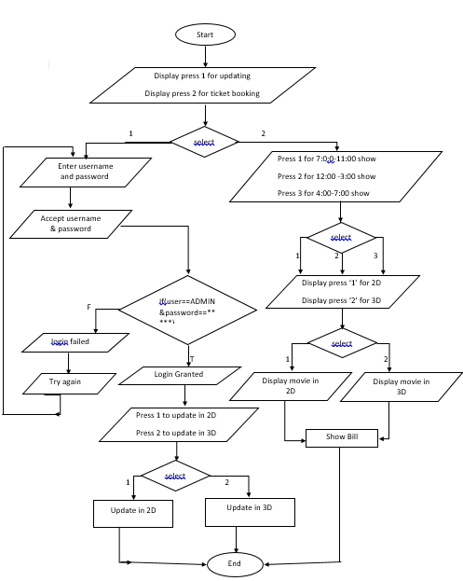

Flowchart diagram of Theatre Management System

5.2 Database

A database contains a collection of related items or facts arranged in a specific structure. So database is a repository for collection of related data or facts. Database programs can also sort lists of data arranged them in alphabetical, numerical or chronological order.
For this software we are using flat file system where single table will include all the attributes of the table.

2MPRCUBE:
show | Time | Hall | Price | Seat

5.3 Back and Front End Tool

As the front end the exe screen of the c Language is used and the data is stored in the excel file so it becomes the back end of the system.

6. Program Source Code
#include<stdio.h>
#include<conio.h>
#include<string.h>
#include<time.h>
#include<stdlib.h>
#include<graphics.h>
FILE *fp,*rp,*bp;
time_t t;
void login();
void booking();
void seat();
void ticket();
void main()
{
intgd = DETECT,gm;
int a;
initgraph(&gd,&gm,"C:\\TC\\BGI");
settextstyle(7,0,5);
outtextxy(80,20,"Welcome to 2MPRCUBE");
settextstyle(4,0,3);
delay(100);
outtextxy(190,70,"Baneshwor,Kathmandu");
settextstyle(3,0,3);
setlinestyle(2,1,4);
line(100,200,600,200);
line(100,330,600,330);
line(250,200,250,330);
line(420,200,420,330);
setcolor(12);
outtextxy(150,170,"Developed on cordination of Group C");
outtextxy(250,200,"-Menuka");
outtextxy(250,220,"-Mijan");
outtextxy(250,240,"-Pemba");
outtextxy(250,260,"-Rinju");
outtextxy(250,280,"-Rojendra");
outtextxy(250,300,"-Rupendra");
setcolor(RED);
setlinestyle(3,2,3);
rectangle(60,30,570,100);
setcolor(GREEN);
rectangle(40,20,600,130);

setcolor(WHITE);
settextstyle(1,0,1);
outtextxy(200,340,"Press Any Key To Continue");
getch();
cleardevice();
closegraph();
initgraph(&gd,&gm,"C:\\TC\\BGI");
setlinestyle(1,0,11);
setcolor(GREEN);
line(10,150,700,150);
line(10,250,700,250);
line(10,160,700,160);
line(10,240,700,240);
printf("\n\n\n\n\n\n\n\n\n\n\n\t\tPress 1 for Administrator Login \n\n\t\tPress 2 for Ticket booking\n\n\n\t\t\t=>" );
scanf("%d",&a);
closegraph();
switch(a)
{
case 1:login();
break;
case 2:booking();
ticket();
break;
}
clrscr();
cleardevice();
printf("\n\n\n\n\n\n\n\n\n\n\t\tThank-You for co-operating with us");
getch();
}
void login()
{
char user[10], pass[10],name[20];
inta,x,y,gd=DETECT,gm,b;
clrscr();
d:
clrscr();
printf("\n\n\n\n\n\n\n\n\n\n\n\n\t\tEnter username:");
scanf("%s",user);
printf("\t\tEnter password:");
scanf("%s",pass);
x=strcmp(user,"ADMIN") ;
y=strcmp(pass,"*****");
if(x==0&&y==0)
{
clrscr();
initgraph(&gd,&gm,"C:\\TC\\BGI");
settextstyle(4,0,5);
outtextxy(120,100,"Login granted");
getch();
cleardevice();
setcolor(RED);
line(70,150,500,150);
line(70,250,500,250);
setcolor(BLUE);
line(70,170,500,170);
line(70,230,500,230);
printf("\n\n\n\n\n\n\n\n\n\n\n\t\t Press 1 for Updating 2d movies\n\n\t\t Press 2 for updating 3d movies\n\n\n\t\t\t=>");
scanf("%d",&b);
switch(b)
{

case 1:
clrscr();
cleardevice();
fp=fopen("theatre.txt","w");
fprintf(fp," ");
fclose(fp);
back:
fp=fopen("theatre.txt","a");
rp=fopen("record.txt","a");
printf("\n\n\n\t\t\tEnter new movie name:");
scanf("%s",name);
fprintf(fp,"%s\t",name);
fprintf(rp,"%s\t",name);
printf("\t\tEnter 1 to update more movies\n\t\t=>");
fclose(fp);
fclose(rp);
scanf("%d",&a);
if(a==1)
goto back;
break;
case 2:
clrscr();
cleardevice();
fp=fopen("theatre2.txt","w");
fprintf(fp," ");
fclose(fp);
fp=fopen("theatre2.txt","a");
rp=fopen("record2.txt","a");
printf("\n\n\n\n\n\t\tEnter new movie name:");
scanf("%s",name);
fprintf(fp,"%s\t",name);
fprintf(rp,"%s\t",name);
fclose(fp);
fclose(rp);
break;

}
clrscr();
cleardevice();
printf("\n\n\n\n\n\n\n\n\n\n\t\tUpdate Completed");
}

else
{
clrscr();
printf("\n\n\n\n\n\n\n\n\n\n\t\t Login failed");
printf("\n\t\tPress 1 to try again\n\t\tPress 2 to exit\n\t\t=>");
c:
scanf("%d",&b);
switch(b)
{
case 1: goto d;
case 2:goto e;
default:printf("\n\t\tEnter either 1 or 2");
goto c;

}
}
e:
getch();
}
void booking()
{

intgd=DETECT,gm;

intm,n,i;
char name1[20],name2[20],name3[20],name[20];
initgraph(&gd,&gm,"C:\\TC\\BGI");
setcolor(GREEN);
line(10,150,700,150);
line(10,220,700,220);
printf("\n\n\n\n\n\n\n\n\n\n\t\tPress 1 for 7:00-10:00 show\n\t\tPress 2 for 12:00-3:00 show\n\t\tPress 3 for 4:00-7:00 show\n\n\t\t\t=>");
scanf("%d",&n);

clrscr();
cleardevice();
switch(n)
{
case 1:
setcolor(GREEN);
setlinestyle(0,0,0);
line(10,130,700,130);
line(10,200,700,200);
printf("\n\n\n\n\n\n\n\n\n\n\t\t Press 1 for 2d Movie\n\t\t Press 2 for 3d Movie\n\n\n\t\t\t=>");
scanf("%d",&m);
clrscr();
cleardevice();
if(m==1)
{
bp=fopen("bill.txt","w");
fp=fopen("theatre.txt","r");
fscanf(fp,"%s%s%s",name1,name2,name3);
initgraph(&gd,&gm,"C:\\TC\\BGI");
setcolor(GREEN);
setlinestyle(3,0,4);
line(10,170,700,170);
line(10,230,700,230);
printf("\n\n\n\n\n\n\n\n\n\n\n\t\tPress 1 for Movie:%s\n\t\tPress 2 for Movie:%s\n\t\tPress 3 for Movie:%s\n\n\t\t\t=>",name1,name2,name3);
printf(">");
scanf("%d",&i);
switch(i)
{
case 1:printf("\n\t\tYour movie is %s",name1);
fprintf(bp,"7:00-10:00 %s 01 200",name1);
break;
case 2:printf("\n\t\tYour movie is %s",name2);
fprintf(bp,"7:00-10:00 %s 02 200",name2);
break;
case 3:printf("\n\t\tYour movie is %s",name3);
fprintf(bp,"7:00-10:00 %s 03 200",name3);
break;
}
getch();
fclose(fp);
fclose(bp);
}
if(m==2)
{
setcolor(GREEN);
setlinestyle(0,0,0);
line(10,130,700,130);
line(10,200,700,200);
fp=fopen("theatre2.txt","r");
fscanf(fp,"%s",name);
printf("\n\n\n\n\n\n\n\n\n\n\t\tYour movie is:%s",name);
getch();
fclose(fp);
bp=fopen("bill.txt","w");
fprintf(bp,"7:00-10:00 %s 04 300",name);
fclose(bp);
}
break;
case 2:
line(10,150,700,150);
line(10,200,700,200);
printf("\n\n\n\n\n\n\n\n\n\n\t\t Press 1 for 2d Movie\n\t\t Press 2 for 3d Movie\n\n\t\t\t=>");
scanf("%d",&m);
clrscr();
cleardevice();
if(m==1)
{
line(10,150,700,150);
line(10,230,700,230);
bp=fopen("bill.txt","w");
fp=fopen("theatre.txt","r");
fscanf(fp,"%s%s%s",name1,name2,name3);
printf("\n\n\n\n\n\n\n\n\n\n\n\t\tPress 1 for Movie:%s\n\t\tPress 2 for Movie:%s\n\t\tPress 3 for Movie:%s\n\n\t\t\t=>",name1,name2,name3);
printf(">");
scanf("%d",&i);
switch(i)
{
case 1:printf("\n\t\tYour movie is %s",name1);
fprintf(bp,"12:00-15:00 %s 01 200",name1);
break;
case 2:printf("\n\t\tYour movie is %s",name2);
fprintf(bp,"12:00-15:00 %s 02 200",name2);
break;
case 3:printf("\n\t\tYour movie is %s ",name3);
fprintf(bp,"12:00-15:00 %s 03 200",name3);
break;
}
getch();
fclose(fp);
fclose(bp);
}
if(m==2)
{
setcolor(GREEN);
setlinestyle(0,0,0);
line(10,130,700,130);
line(10,200,700,200);
fp=fopen("theatre2.txt","r");
fscanf(fp,"%s",name);
printf("\n\n\n\n\n\n\n\n\n\n\t\tYour movie is:%s",name);
getch();
fclose(fp);
bp=fopen("bill.txt","w");
fprintf(bp,"12:00-15:00 %s 04 300",name);
fclose(bp);
}
break;
case 3:
line(10,150,700,150);
line(10,200,700,200);
printf("\n\n\n\n\n\n\n\n\n\n\t\t Press 1 for 2d Movie\n\t\t Press 2 for 3d Movie\n\n\t\t\t=>");
scanf("%d",&m);
clrscr();
cleardevice();
if(m==1)
{
bp=fopen("bill.txt","w");
fp=fopen("theatre.txt","r");
fscanf(fp,"%s%s%s",name1,name2,name3);
printf("\n\n\n\n\n\n\n\n\n\n\n\t\tPress 1 for Movie:%s\n\t\tPress 2 for Movie:%s\n\t\tPress 3 for Movie:%s\n\n\t\t\t=>",name1,name2,name3);
printf(">");
scanf("%d",&i);
switch(i)
{
case 1:printf("\n\t\tYour movie is %s",name1);
fprintf(bp,"16:00-19:00 %s 01 200",name1);
break;
case 2:printf("\n\t\tYour movie is %s",name2);
fprintf(bp,"16:00-19:00 %s 02 200",name2);
break;
case 3:printf("\n\t\tYour movie is %s",name3);
fprintf(bp,"16:00-19:00 %s 03 200",name3);
break;
}
getch();
fclose(fp);
fclose(bp);
}
if(m==2)
{
setcolor(GREEN);
setlinestyle(0,0,0);
line(10,130,700,130);
line(10,200,700,200);
fp=fopen("theatre2.txt","r");
fscanf(fp,"%s",name);
printf("\n\n\n\n\n\n\n\n\n\n\t\tYour movie is:%s",name);
getch();
fclose(fp);
bp=fopen("bill.txt","w");
fprintf(bp,"16:00-19:00 %s 04 300",name);
fclose(bp);
}
break;
}

}
void ticket()
{
intgd = DETECT,gm;

char h[4],n[20],tt[20],p[5];
initgraph(&gd,&gm,"C:\\TC\\BGI");
cleardevice();
settextstyle(7,0,5);
outtextxy(80,20,"Welcome to 2MPRCUBE");
settextstyle(4,0,3);
delay(100);
outtextxy(190,70,"Baneshwor,Kathmandu");
setlinestyle(3,2,3);
rectangle(60,30,570,100);
setcolor(GREEN);
rectangle(40,20,600,130);
outtextxy(210,130,"Booking confirmed");
time(&t);
printf("\n\n\n\n\n\n\n\n\n\n\t\tShow Date:%s",ctime(&t));
bp=fopen("bill.txt","r");
fscanf(bp,"%s%s%s%s",tt,n,h,p);
printf("\n\tShow Time:%s",tt);
printf("\n\tShow Name:%s",n);
printf("\n\tHall No.:%s",h);
printf("\n\tPrice:Rs.%s",p);
srand(time(NULL));
printf("\n\tSeat No.:%d",rand()%400);

getch();
}

7. User Manual Guide

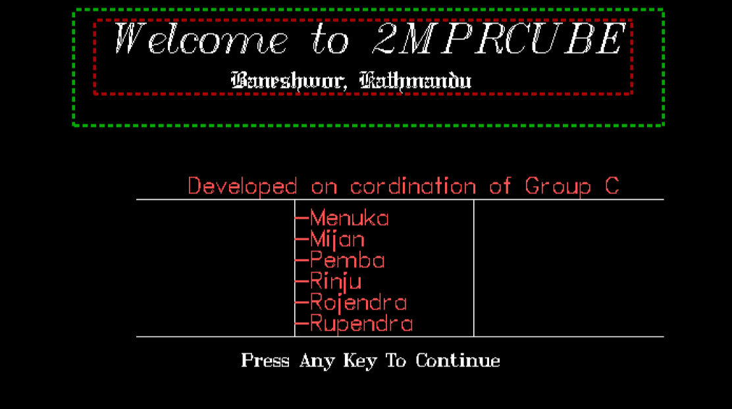
This is a welcome page of our project on Theatre Management System.

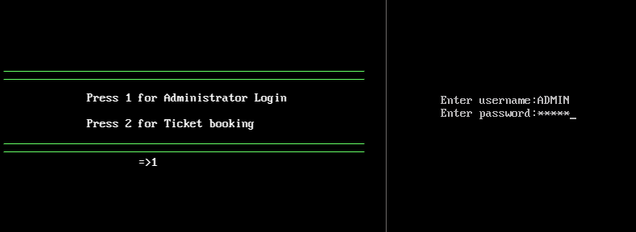
By pressing 1 Administrator Login page will be displayed.

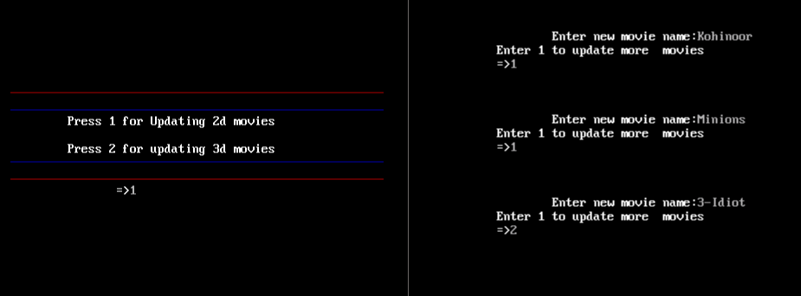
If Login Granted then user can update either 2d or 3d movies.
By pressing 1user(administrator) can update 1d movie.

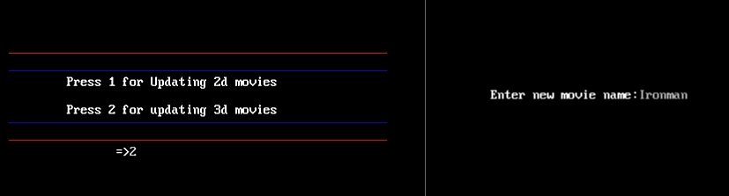
By pressing 2 administrator can update 2d movie.

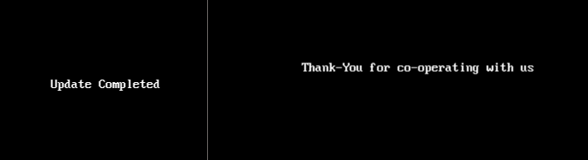
This Page Show Completion of Update Part

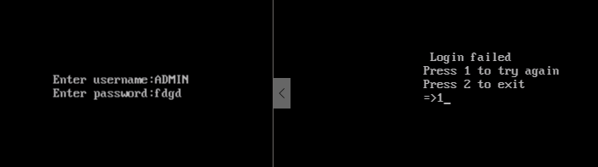
If Keyword of Username or Password is wrong then above screen is Displayed

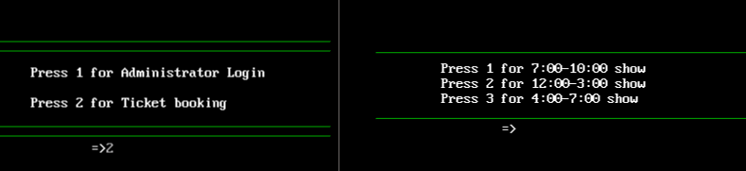
By Pressing 2 Costumer can Forward for Ticket Booking

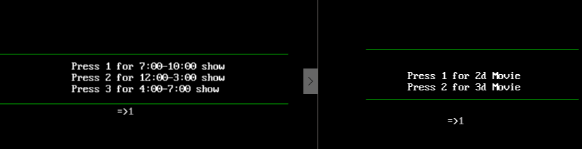
By Pressing 1 Costumer can Choose Show Time and Type

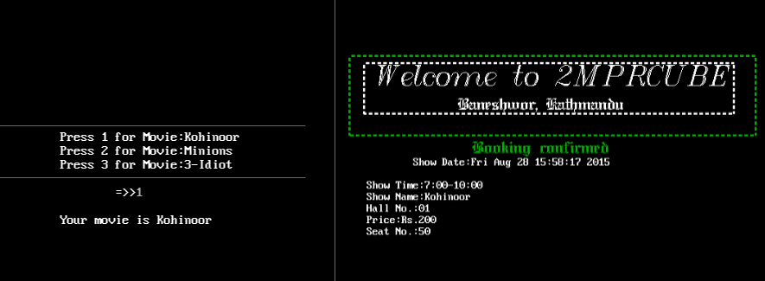
Costumer 2D Movie and Confirmation of ticket

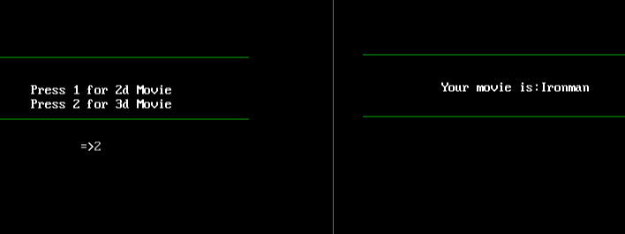
The Single 3D Movie is Displayed

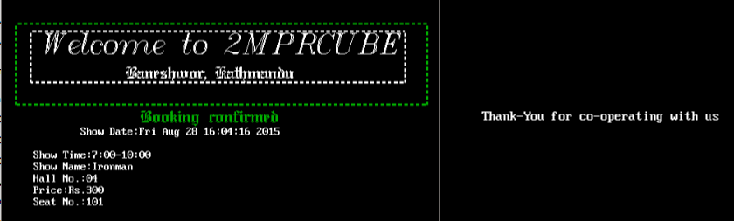
Confirmation of 3D Movie and End Of System

8. Conclusion

After the detailed study of “Theatre Management System”of one of the theatre in Kathmandu, we have developed this system.
Bibliography

1. Data Structure and Algorithm using c and c++ by Langsam Yedidyah Moshe J. and Tennenbaum Aaron M.

